*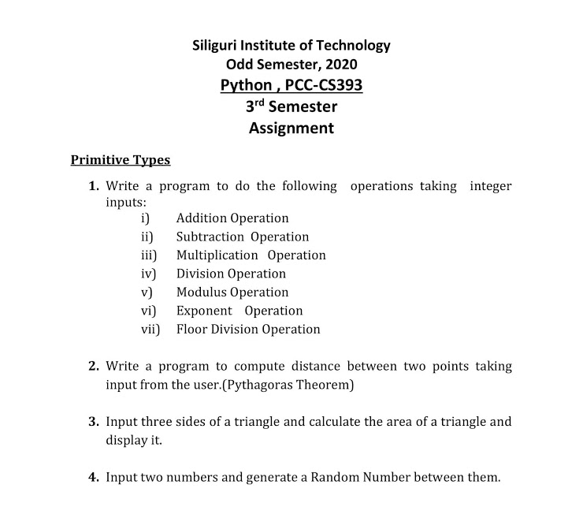****Exercise 1 –***

***Program –***

flag=1

def calc(x,y,operator):

if(operator=="1"):

return x+y

elif(operator=="2"):

return x-y

elif(operator=="3"):

return x*y

elif(operator=="4"):

if(y!=0):

return x/y

else:

return("Can't divide by Zero(0).")

elif(operator=="5"):

if(y!=0):

return x%y

else:

return("Error.")

elif(operator=="6"):

return x**y

elif(operator=="7"):

if(y!=0):

return x//y

else:

return("Can't divide by Zero(0).")

else:

print("Sorry try again.")

return 0

while(flag==1):

print("Menu:")

print("1. Addition")

print("2. Subtraction")

print("3. Multiplication")

print("4. Division")

print("5. Modulus/Remainder")

print("6. Exponent")

print("7. Floor Division")

x=int(input("Enter your 1st number: "))

y=int(input("Enter your 2nd number: "))

operator=(input("Enter the operation (1-7): "))

print("Result: "+ str(calc(x,y,operator)))

intake=input("Do you wish to continue? (Press y to continue or any key to exit.): ")

if(intake=="Y" or intake=="y"):

flag=1

else:

flag=0

break



***Exercise 2 –***

***Program –***

import math

flag=1

def distance(x1,y1,x2,y2):

r=math.sqrt(pow((x1-x2),2)+pow((y1-y2),2))

print("Distance: "+ str(r))

while(flag==1):

print("Give your first point:")

x1=int(input("x1: "))

y1=int(input("y1: "))

print("Give your second point:")

x2=int(input("x2: "))

y2=int(input("y2: "))

distance(x1,y1,x2,y2)

intake=input("Do you wish to continue? (Press y to continue or any key to exit.): ")

if(intake=="Y" or intake=="y"):

flag=1

else:

flag=0

break

**

***Exercise 3 –***

***Program –***

import math

flag=1

def area(x,y,z):

if((x+y>z) and (y+z>x) and (z+x>y)):

s=(x+y+z)/2

ar=math.sqrt(s*(s-x)*(s-y)*(s-z))

print("Result: "+ str(ar))

else:

print("Sum of two sides is smaller than third side.")

while(flag==1):

x=int(input("Enter your 1st side: "))

y=int(input("Enter your 2nd side: "))

z=int(input("Enter your 3rd side: "))

area(x,y,z)

intake=input("Do you wish to continue? (Press y to continue or any key to exit.): ")

if(intake=="Y" or intake=="y"):

flag=1

else:

flag=0

break

*****Exercise 4 –***

***Program –***

import random

flag=1

while(flag==1):

x=int(input("Enter your 1st number: "))

y=int(input("Enter your 2nd number: "))

if(x<=y):

result=random.randint(x,y)

print("Your number is " + str(result))

else:

print("Error")

intake=input("Do you wish to continue? (Press y to continue or any key to exit.): ")

if(intake=="Y" or intake=="y"):

flag=1

else:

flag=0

break